SESSION 13 ASSIGNMENT 1

**Problem**: Create a Scala application to find the GCD of two numbers.

Code:

class session_13_1 {

//Recursive iteration until b becomes zero

def gcd(a:Int, b:Int): Int = {

if(b == 0) a else gcd(b,a%b)

}

}

object exec_gcd extends App {

var gcd = new session_13_1

var a=10;

var b=14;

println("GCD of " + a + " & " + b + " is " + gcd.gcd(a,b))

println("GCD of " + (a+1) + " & " + (b+4) + " is " + gcd.gcd(a+1,b+4))

}

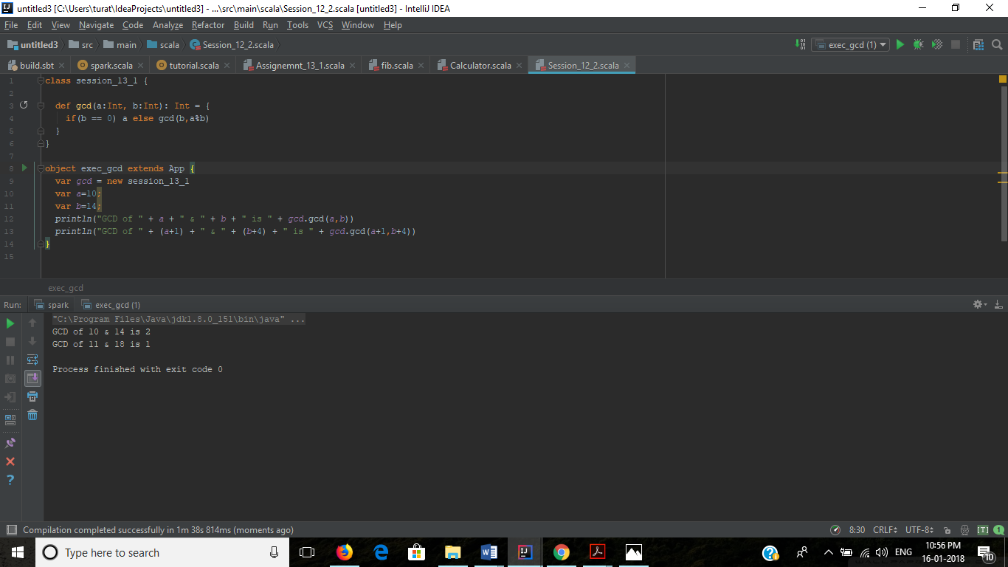

**Output**:

GCD of 10 & 14 is 2

GCD of 11 & 18 is 1

Process finished with exit code 0